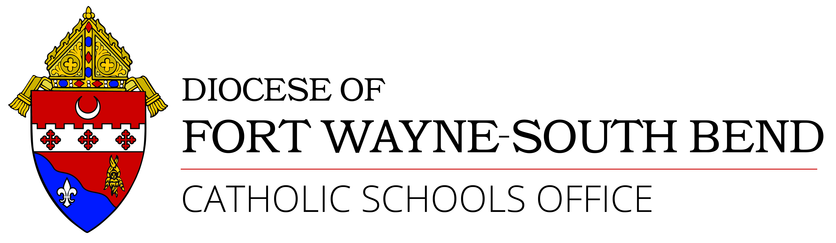

Aspiring Catholic Leaders Program
Approved Educational Leadership Program List

Catholic school leaders should be proficient in the National Standards and Benchmarks for Effective Catholic Elementary and Secondary Schools. These benchmarks include Mission and Catholic Identity, Governance and Leadership, Academic Excellence, and Operational Vitality. We are blessed to have programs that cover these key areas in addition to state licensure requirements for a building level administrator. Therefore, preference is given for Catholic programs like those listed below. If there is a hardship that prevents attendance to a Catholic program, please contact the Catholic Schools Office, Personnel Assistant to discuss further options.

- Mary Ann Remick Program – University of Notre Dame
- Catholic School Leadership – Loyola University, Chicago
- Educational Leadership (MSE) with Catholic schools course sections – University of Dayton
- Master of Science in Educational Leadership – Franciscan University of Steubenville
- Master’s in Educational Leadership with Catholic schools concentration – Marian University, Indianapolis
- Educational Leadership – Boston College
- Master of Catholic School Leadership – University of Dallas
- M.A./Ed.S, Catholic School Leadership – Seton Hall University
- Educational Leadership, M.A. with Catholic school concentration – St. Louis University (All courses are taught in a four-Saturday format (Fall and Spring), and in an eight-week period spanning mid-May to mid-July in the summer.)

