Collection Process

Sample Pledge Card (Fits in a #9 envelope)

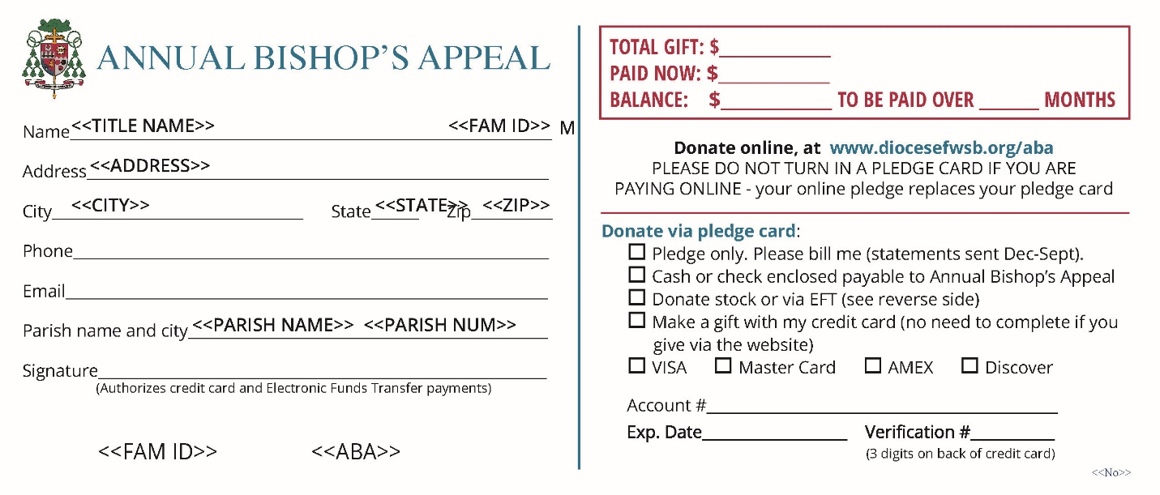

Reverse side of pledge card

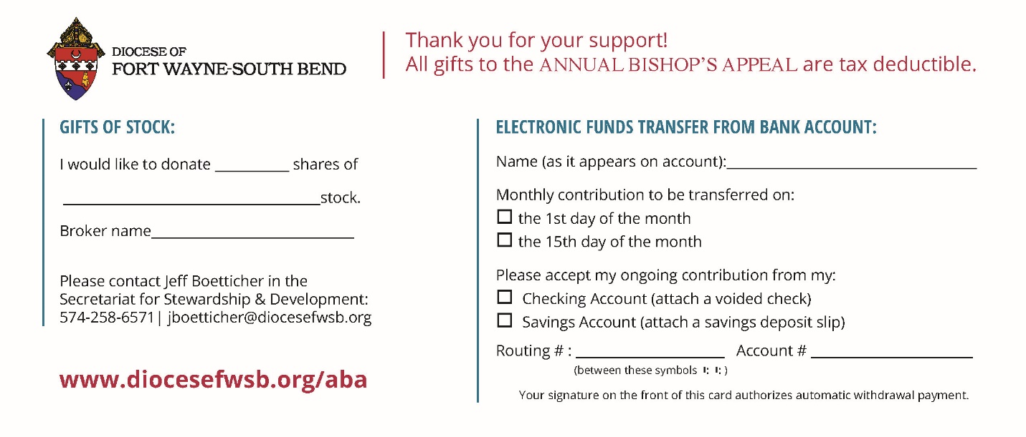

Auditing Procedures- Receiving Pledges

If parishioners are completing blank pledge cards in church, the information they write on the cards should be transferred to an excel spreadsheet, which will be provided for each parish. Enter the donation amounts for each donor on your excel spreadsheet, and fill out a Transmittal Report, then email to the Business Office. If you are not using the excel spreadsheet, you need to rewrite the pledges on each donor’s preprinted pledge card (if you use preprinted pledge cards, you should have already ordered them with your ABA supplies), which are then sent to the Diocesan Business Office to be scanned. If you are using the excel spreadsheet and have entered the donation amounts, you will not need to send the preprinted pledge card, because it does not need to be scanned. Please note, credit card and EFT pledges cannot be submitted on an excel spreadsheet -these pledge cards will need to be sent to the Business Office for processing (via FedEx, see instructions below). For credit cards and EFT, you must rewrite the donor’s information on a preprinted pledge card (so it has their Family ID number) and send that to the Business Office with a Transmittal Form. When submitting credit card donations, please separate into two batches: Credit Card, Pledged & Paid in full, and Credit Card, Balance Due. Please fill out a Transmittal form for each batch.
Please encourage your parishioners to go online to enter their credit/debit card donations, as this is a more secure method for them, and also saves processing time for parish and diocesan staff.

If you do not have a pre-printed pledge card for a family, fill out pledge on a blank card, and include the Family ID number (look it up in ParishSoft). Please do not use another family’s pre-printed pledge card and write in a new family, because the pre-printed cards have a family ID at the bottom of the card specific to the family printed on the card. It is important to have the correct family’s pledge with the family ID as the cards are scanned and imported into our pledge records.

- The parish must already have donor families set up in the ParishSoft census program.

- If the family is not entered when the diocese receives the pledge cards, the diocese will enter the family as a Registered, Contributor Only so that the parish receives credit for the pledge.

- After the pledge has been entered the parish can keep this family record or remove them.

You may now enter gifts for both Major/Advance donors and General donors on your excel spreadsheet. These include “Pledge Only”, “Gift with Pledge”, and “Paid in Full” using a check for payment. Again, EFT and Credit Card gifts cannot be submitted on an excel spreadsheet.

Bank Deposits

1. Run a calculator tape on checks/monies received.
2. Run another tape on "Paid Now" Section of the pledge cards.
3. The two tapes must be in agreement before you send the monies to the bank for deposit.
4. When you record the deposit in the parish books, the entry should be:

Debit Cash Account #110.110 $_________
Credit Annual Bishop’s Appeal Transfer Account #220.110 $_________

Sending Cards to the Diocesan Business Office

Please keep credit card and electronic transfer pledges with payments separate from regular pledges with payments by check. A separate transmittal form should be completed for credit cards and electronic transfers. Please make sure that all donor information and pledge amounts are legible.

When sending cards to the Diocesan Business Office, please do the following:

1. Most parishes use the excel file to submit pledges (preferred method), and so do not need to send pledge cards to the Business Office. For the larger parishes (if you have more than approximately 150 cards for the week), please make several batches, each one not more than 1½" high, and each with its own parish check (A sufficient number of “first class postage paid envelopes” will be provided to each parish for mailing to the Diocesan Business Office.

2. Run a calculator tape on the Total Gift section of the cards.

3. Run another calculator tape on the Paid Now section of the cards.

4. Send the cards, the balanced calculator tapes, the transmittal form, and a check for the amount paid--made payable to the Annual Bishop's Appeal. Please do not send cards for “zero” pledges or calculate “zero” pledges in your totals.

Please issue a separate Transmittal Form and Check for each stack of cards.

5. When you record the check to the diocese in the parish books, the entry should be:
Debit Annual Bishop’s Appeal Transfer Account #220.110 $ ________
Credit Cash Account #110.110 $ ________

6. Most parishes, depending on size, should send in their pledge cards weekly during October and November. All cards are due in the Diocesan Business Office by November 15th. Please do not hold pledge cards. Your donors may not receive proper tax credit for the year they donated if you do not get their pledges sent in by the end of November.

Use of Credit Card

The donor may go to our website and make their donation. If they prefer to write their credit card donation on a blank pledge card, they should write in the type of credit card, account number, expiration date and the three-digit code on the pledge card. The parish then needs to rewrite the donor’s information on a preprinted pledge card (so it has their Family ID number) and send that to the Business Office with a Transmittal Form. Please make sure pledge cards are legible and have the correct Family ID so we are able to process them. When submitting credit card donations, please separate into two batches: Credit Card, Pledged & Paid in full, and Credit Card, Balance Due. Please fill out a Transmittal form for each batch.

No bill will be sent to donors using credit cards or electronic transfer unless the credit card has expired or there are not enough funds in the account.

Sending Credit Card pledges & payments to the Business Office via FedEx

Credit card payments sent from parishes to the Diocese should be sent via secured carrier. Therefore, we are sending you an initial supply of FedEx envelopes for this purpose. When you run low, please call Claire Klinedinst in the Stewardship & Development Office, at 574-258-6571 to have your supply replenished. To fill out the FedEx label:

- Section 1- enter date
- Section 2- skip
- Section 3- Fill in Deb Gase in “name”, Diocese of Fort Wayne-South Bend, 915 S. Clinton St., Fort Wayne, IN 46802-2601.
- Section 4- Check “FedEx Express Saver”
- Section 5- Check “FedEx Envelope”
- Section 6- Check “No” where it asks whether the package contains dangerous goods
- Section 7- Check “Recipient”

Keep the top copy of the air bill for your records, then insert the air bill in the plastic pouch on the back of the FedEx envelope. Call 1-800-463-3339 to schedule pickup or drop the envelope in a FedEx drop off site. If you have any questions, please call the Diocesan Business Office at 260-399-1421.

Electronic Transfer

What is electronic contribution?

Electronic contribution is an automatic transfer from your checking or savings account, which allows you to make contributions to the Annual Bishop’s Appeal without writing checks. An alternative is going online to diocesefwsb.org/aba and donating with your debit card.

How do I sign up for electronic contribution?

Complete and sign the authorization form on your pledge card and return it to the parish office with a voided check or savings deposit slip.

How is my electronic contribution automatically deducted from my account?

Once you authorize the transfer, your specified contribution is electronically transferred directly from your checking or savings account to your parish Annual Bishop’s Appeal account- donor’s signature on the of the front of the pledge card authorizes payment.

When will my contribution be deducted from my account?

Your contribution will be deducted from your account on the 1st or the 15th of the month (whichever you specify). You can set up payment for up to 12 months.

What if I change bank accounts?

If you change bank accounts, you can simply call the Diocesan Business Office (260) 422-4611, extension 3340, and give them the new information, or you can mail the new account information to the Diocesan Business Office, P.O. Box 390, Fort Wayne, Indiana 46801.

How much does electronic contribution cost?

It costs you nothing and saves you time.

What if I try electronic contribution and do not like it?

You can cancel your authorization for electronic contribution any time by notifying us in writing or email: jboetticher@diocesefwsb.org.

Stock Donations

Stock donations to the Diocese of Fort Wayne-South Bend for the Annual Bishop’s Appeal continue to increase annually. We want to accommodate our donors in the most effective way possible; however, we also want to realize the greatest net proceeds to the beneficiary location. To help accomplish this, we are offering a program through Northern Trust. Their fee is a flat $30 for 1-700 shares and a flat five cents per share for trades over 701 shares. The net proceeds will be greater in most transactions with these terms.

Account information for Northern Trust is as follows.

Northern Trust Securities, Inc. (NTSI)
Account Name Diocese of Fort Wayne-South Bend, Inc.
Account # NT2-085324
DTC# 0226

Please have your broker inform the diocesan business office of:

Name of donor
Name of stock
Number of shares
Date of stock transfer
Purpose of the gift
Your broker can inform by letter:
Jeff Boetticher,1328 W. Dragoon Trail, Mishawaka, IN 46544
Or e-mail to jboetticher@diocesefwsb.org
Phone # 574-258-6571

Payments

Monthly payments on pledges to the Annual Bishop’s Appeal should be made directly to the diocese, not to the parish. All checks should be made out to the Annual Bishop’s Appeal. Billing for pledges is for 10 months, December to September, and monthly statements/ reminders will be sent out by the Business Office.

Payments received in the Offertory

While donors should send all payments directly to the diocese, sometimes they drop them in the collection basket. When that happens, just write a note saying "Pledge Payment" and paper clip it to the check; please do not staple. Then, mail both to the Diocesan Business Office.

Please do not send a duplicate pledge card with a payment that is made on a previous pledge.

Please do not staple anything to the pledge card. The pledge card is the “main source document” and must be kept free from holes or scratches so it can be read properly on an automated machine.

Please send your donations to the Business Office in a timely manner, so your donors receive tax benefits in the current tax year. For example, a donor gives a check to the parish November 15th, but the check is not sent to the Business Office until January 2nd. The donor may not get the tax credit in the year they intended.

Transmittal Report

Please use the Transmittal Report form when reporting (see last page for example, and go to https://diocesefwsb.org/aba-toolkit/ to print this form).

Mail or deliver this form and your parish check in the prepaid envelope provided to:

Data Processing
Diocesan Business Office
Diocese of Fort Wayne-South Bend
P.O. Box 390
Fort Wayne, IN 46801

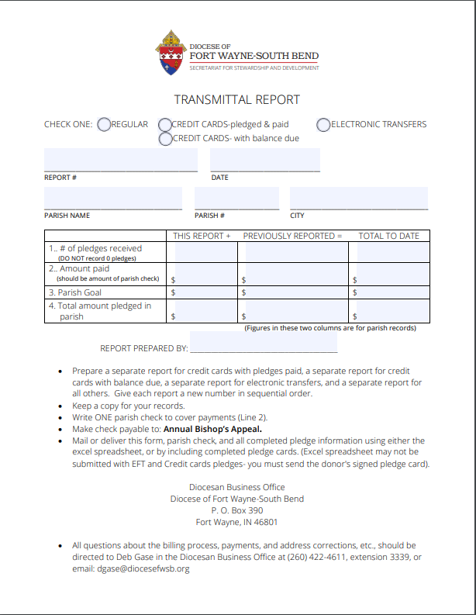

Goal Calculation- Sample of 2022/23 Annual Bishop’s Appeal Goal Calculation

- The General Phase Goal for your parish this year is $53,953

That figure is based on your 2017/2018 Total Parish Offertory Income, which was $529,862.

That figure is 1.28% of the Total Diocesan Offertory Income which was approximately $41,246,933.

II. Your Advanced Gift Goal is $21,182.

That figure is computed as follows:

- Take the average of your Large Gifts (Gifts over $1,000 for the 2019, 2020 and 2021 Appeals;
- b) Take that same figure as a percentage of the Advanced Gifts goal which is $1,399,991.

III. Your Total Goal for the 2022/23 Annual Bishop's Appeal is $75,135.

Any amount pledged and paid over and above the parish's assigned goal (overage) will be rebated back as payments come in. This rebate process will go into effect unless the parish owes funds from previous Appeals.

