Introduction

The Annual Bishop’s Appeal is an important annual fund for the Diocese of Fort Wayne-South Bend. The donations received help fund various ministries, programs and services that we do best collectively as a diocese, rather than individual parishes.

Each year the business office determines the Bishop’s Appeal total goal and assigns each parish a respective goal amount according to the prescribed goal calculation. The parish goal is mandatory and the parish receives all funds collected over their assigned goal.

Goal Calculation: Sample of 2022/23 Annual Bishop’s Appeal Goal Calculation

I. The General Phase Goal for your parish this year is $53,953

That figure is based on your 2017/2018 Total Parish Offertory Income, which was $529,862.

That figure is 1.28% of the Total Diocesan Offertory Income which was approximately $41,246,933.

II. Your Advanced Gift Goal is $21,182.

That figure is computed as follows:

A) Take the average of your Large Gifts (Gifts over $1,000 for the 2019, 2020 and 2021 Appeals;
B) Take that same figure as a percentage of the Advanced Gifts goal which is $1,399,991.

III. Your Total Goal for the 2022/23 Annual Bishop's Appeal is $75,135.

Any amount pledged and paid over and above the parish's assigned goal (overage) will be rebated back as payments come in. This rebate process will go into effect unless the parish owes funds from previous Appeals.

Letter to Donors

The Appeal process is designed according to best practices, which includes contacting every household in the diocese with an invitation to participate in the Annual Bishop’s Appeal. This invitation, which is through a mailing, is handled by the Diocesan Development Office and assisted by the Annual Bishop’s Appeal Advisory Committee.

General Chairpersons: Mr. Dan Florin
Mrs. Kelly Florin

Fort Wayne Area Vice Chairpersons: Mr. Dan Landrigan
Mrs. Elizabeth Landrigan

South Bend Area Vice Chairpersons: Mr. Tim Dolezal
Mrs. Kate Dolezal

There are no dinners this year- instead, each registered and active parishioner in the diocese will receive a letter from Bishop Rhoades, with a personalized pledge card, brochure, and reply envelope.

Major Donor Follow-up letters from Bishop Rhoades are mailed from the Stewardship and Development office to Advanced Gift non-respondents in early November. This year, donors who gave $500 and more to last year’s appeal are in the ‘major donor” group.

The Major Donors (less than 4% of total diocesan families) pledge about 51% of the total amount pledged in an average year. All major donor pledges are credited to donor’s respective parish goal.

Parish Phase

The Parish phase is conducted within each parish. A successful parish Appeal is directly related to the enthusiasm and motivation of the Appeal parish leadership, beginning with the Pastor.

The Pastor is asked to selectively recruit an Appeal Chairperson (or couple) to assist with the process of the Appeal in the parish. The lay leader(s) should be invited to the Appeal Leadership dinner held in early September.

The Appeal Chair’s main objective is to apply an effective process (presented in this manual) asking everyone in the parish to prayerfully consider a gift to the Bishop’s Appeal. Complete coverage of your parish will result in greater parish participation and a greater amount of funding to support the ministries and services of the diocese, as well as increasing your parish overage.

It is unreasonable to expect success from just one weekend’s effort or one solicitation attempt. Successful parishes try to contact each parish household by various means (in-pew ask, follow-up letter or email, parish app, parish website, pulpit announcements and bulletin reminders).

Adopt the Annual Bishop’s Appeal as your own by identifying a financial need of your parish and communicate how your parish will use the overage for the specified parish need.

Utilize the materials provided and follow the plan. In-Pew solicitation is a very effective approach.

Remember that no gift is too small (and of course, no gift too large). We would like everyone to participate. Do not suggest a specific amount. Simply state that the suggested guideline for generosity is one percent of household income.

Materials for the Annual Bishop’s Appeal
ABA Supply Order forms are sent to the parishes to be completed and returned to the Diocesan Development Office in the spring of the year, and include the following materials:

- Appeal video- use link sent, also available in Parish Toolkit (also available in Spanish)
- Appeal Brochures (available in English and Spanish)
- Blank Pledge Cards for In-Pew sign-ups (available in English and Spanish)
- Preprinted Pledge Cards (must be ordered)
- Preprinted #9 Return Envelopes (must be ordered)
- Posters (printed two sides in English/Spanish)
- Thermometer tracking poster

The following materials are available at https:/diocesefwsb.org/aba-toolkit/

- ABA Timeline
- Transmittal Report
- Bulletin Inserts
- Social Media Graphics
- Collection Process
- How to fill out the excel spreadsheet
- Pastor Role
- ABA video
- Appeal Manual and excerpts
- How to run a Parish Master Report
- Spanish Materials

Parish Appeal Process

Volunteer Sunday

Parishes should have a volunteer committee in place.

The Pastor should briefly remind the parishioners of:

- Ministries and services supported by the Annual Appeal and why they are important to the life of the Church. (Refer to the Appeal brochure.)
- Specific ways the Appeal has helped your parish.
- Previous successful Appeals allowed for the parish overage to be used for
__________________, ___________________, and _________________.
- The pastor’s letter and brochure will be sent to each household during the following week.

The Pastor should inform the parishioners that:

- Key people have accepted leadership positions at the parish level. Mention names, and thank them in person, from the pulpit and in the bulletin.

The Pastor should ask the parishioners to:

- Help lighten the load of parish leaders by committing to be a volunteer at that time.

- Prospective volunteers are to contact __________________ , the committee chair.

Lay Presenter

A lay presenter can play an effective role as part of the Appeal process, because despite our best efforts to communicate through the DVD and written materials, letters, brochures, and posters, some people put off making a pledge. The use of the lay presenter gives a personal witness that can make the Annual Bishop’s Appeal more real and personal for the average parishioner.

Who should present? The Pastor and Annual Bishop’s Appeal parish leaders know the parishioners and probably have an idea of who would be an effective speaker. The chairperson might be an option, or you might want to use some of the following criteria in making your decision:

- A good speaker who is energetic, enthusiastic and honest
- A long-time parishioner
- Someone who has helped conduct the Appeal in previous years
- A consistent donor to the Annual Bishop’s Appeal
- An active member of a parish organization such as Parish Council, Stewardship Committee, School Board, Finance Committee
- Someone visible: A Lector, Eucharistic Minister, or Cantor
- A sales professional with the skills to convey the Appeal message

When should the talk take place? - The lay presenter should speak the weekend before Pledge Sunday for no more than five minutes after the homily or at the end of Mass on Kick-off Sunday (timing during Mass is at the Pastor’s discretion).

The lay speaker should refer to the Appeal brochure to give a brief outline of how the Appeal provides ministries and services, and how money equates to ministry. The presentation is to provide fellow parishioners with a reason to give.

- We help change lives when we share our God-given gifts with others
- Together, as a family of parishes, we can offer ministries that no one parish can offer alone. Without Annual Bishop’s Appeal funding, thousands would be left without the help they need
- Each of us are helped by the many services made possible by the Annual Bishop’s Appeal
- We are called to participate in Christ’s work through the works of the Church
- Our parish benefits from the ministries and services funded by the Annual Bishop’s Appeal
- Our parish benefits with a successful Appeal because all funds over goal are returned to our parish

Tell people that you have made a pledge and invite them to do the same. If you were able to increase the amount of your pledge since last year, mention this as part of your presentation. Encourage people to make a ten-month pledge that is payable between the months of December and September or a 12-month credit card or electronic transfer pledge. Close your remarks with a strong finish. You may select a prayer, a short story, a reference to Scripture, or a phrase about giving. Be sure to thank the parishioners for past support and in advance for their gift this year.

In-Pew Solicitation

In-Pew solicitation is an effective approach to obtaining gifts and pledges for the Appeal; many parishes use this method and have been very successful. If carried out thoroughly, this method increases both the number of donors and the dollars contributed with a minimal amount of volunteer time.

Do the following on Pledge Sunday, September 25, 2022:

- Show the Appeal video.
- On Pledge Sunday, have blank Appeal pledge cards and pens (and #9 envelopes, if you provide them) in the pews. Ask the ushers to replenish the supply before each Mass (if your parish does not have pews, instruct the ushers when to pass out the pledge cards and pens).
- Remind donors they may also make their donation on the website, diocesefwsb.org/aba
- The Pastor shares brief remarks in support of the Annual Bishop’s Appeal. The Appeal is a means of expressing support for Bishop Kevin Rhoades and the work of Christ throughout our diocese. (Refer to the Appeal brochure.) Ask for a prayerful and generous response.
- The priest or a lay person could provide step-by-step instructions on filling out the pledge cards.
- The ushers are asked to collect the completed pledge cards after people have had sufficient time to complete them.
- Remind people that it is important for each family to fill out a pledge card, even if they have chosen to make a small gift. Explain that a completed pledge card will save parish follow-up letter and telephone call.
- The support and endorsement of the Pastor and chairperson are critical elements for the success of the In-Pew method.

Follow-Up

Follow up is an important part of the Annual Bishop’s Appeal process. It is intended to reach those parishioners in your parish who have not yet turned in an Appeal pledge card. Not all parishioners attend Mass at their home parish on Pledge Sunday. By repeating your request on these follow-up Sundays, many who were absent on Pledge Sunday will be asked to make a gift to the Appeal. Be sure to remind parishioners (from the pulpit and in the bulletin) to complete a pledge card for the following two Sundays after Pledge Sunday.

After the second Follow-up Sunday, two additional methods of follow up will add to the success rate of your parish’s campaign: follow-up letter from the Pastor and telephone follow up (even if a simple voice mail is left). Prior to doing either of these, we suggest you review your online giving report to remove donors from your follow-up list who have already given.

Pastor’s Follow-Up Letter

Bishop’s letter, which will be sent to all parishioners in September, 2022, replaces the initial Pastor’s letter, so we ask all Pastors to please send a follow-up letter instead. The Pastor’s follow up letter should be sent approximately one month after Pledge Sunday (late-October) to all families who have not completed a pledge card. Parishioners should be invited to return their completed pledge card in the offertory collection, or simply mail to the parish office in the return envelope provided by the parish.

Telephone Follow-up:

This follow-up method could be done as a Phone-a-thon if the parish has access to several telephones in one location. Or, it may also be conducted from a distributed phone list and each volunteer can call from their individual phone.

Phone contact can be a very effective way of reaching the remaining non-respondent members of the parish during this follow-up phase even if the volunteer is only able to leave a voice mail message, followed up with a mailer.

Prior to making the calls, have a mini training session for volunteers to acquaint them with the Annual Bishop’s Appeal and the ministries and services supported by the Appeal. Keep in mind that the people the volunteers are calling might have questions or concerns that stopped them from making their pledge at the time the other members of the parish made their commitment. Provide a copy of the Telephone Follow up Script to the volunteers.

Prepare a list of parishioners (complete with phone numbers) who have not made a pledge. This will be the working list for the volunteers. Allow volunteers to choose the homes they will call.

Provide blank pledge cards for the volunteers to enable them to fill in the name, address, and amount of pledge over the phone.

Pastor’s Thank You Letter

The success of all future Annual Bishop’s Appeal campaigns depends on a human courtesy: thanking people for their generosity. All parishioners who choose to make a pledge to the Annual Bishop’s Appeal need, and deserve, to know that their generosity is appreciated.

Some experts say that we must thank people eight times, in eight different ways. A specific number is not as important as keeping in mind that we cannot say “thank you” enough. We all like to know that we are making a difference in the lives of others. A well-planned, creative “thank you” has potential for expressing such a message.
Thanking people gives us an opportunity to let people know that their gift has impacted the lives of other people within our diocese. It is also a good way to reinforce the stewardship message of gratitude by thanking the donor for sharing God’s gifts in service of others.

Every donor to the Appeal should be individually thanked by the Pastor with a letter. Also, the entire parish should be thanked publicly and repeatedly from the pulpit and in the bulletin. This will show gratitude to those who sacrificed for the work of the Church, and also implicitly remind those who may not have given to the Appeal. Please do not neglect this step in your parish Annual Bishop’s Appeal process. You will reap its rewards in future years.
We provide templates of pastor letters for you, which you may choose to modify to your liking. You will find them on the ABA website Parish Toolkit, at https:/diocesefwsb.org/aba-toolkit/

Important Dates- 36th Annual Bishop’s Appeal, 2022/2023

2022, ABA 36 | Action
Tuesday, July 5, 2022 | ABA 36 website goes live
Friday, July 8, 2022 | ABA Parish Toolkit updated
7-8-22 through 9-16-22 | ABA packet mailed to all households, sent by the Stewardship & Development Office. Includes a letter from Bishop, ABA brochure, pledge card, and return envelope. (Early parishes will mail 7-8-22)
Beginning 9-1-22 | Thank-you letters mailed from Bishop for all donors. Stewardship & Development sends these.
Sunday, September 11 | Volunteer recruitment in parishes (if applicable)
Sunday, September 18 | “Kick Off” Sunday – Lay presenter
Sunday, September 25, 2022 | Pledge Sunday – Show the ABA video and do in-pew solicitation
Sunday, October 2 | Parishes: Appeal thank you and reminder from pulpit and bulletin.
Sunday, October 9 | Parishes: Thank you and follow up Sunday. In-Pew follow up. Begin sending Pastor’s thank you letter.
Sunday, October 16 | Second thank you and follow-up Sunday at parishes
Week of October 17th | Parishes send Pastor’s follow-up letter to non-respondents. (Parish extracts information using Parish Master Report, in ParishSoft)
First week of November 2022 | Stewardship & Development Office sends a follow-up letter to major donors who have not yet given (returns mailed to FW)
First week of November 2022 | Parishes conduct telephone follow up to non-respondents, even if you only leave voicemail.
Sunday, November 13 | Final ABA Sunday (All follow-up efforts should be completed) Thank parishioners for their generosity – from pulpit, in bulletin and letter.
Monday, November 14, 2022 | All pledge cards are due in the Diocesan Business Office Data Processing so that the first statements can be mailed to donors in early December.

Collection Process

Sample Pledge Card (Fits in a #9 envelope)

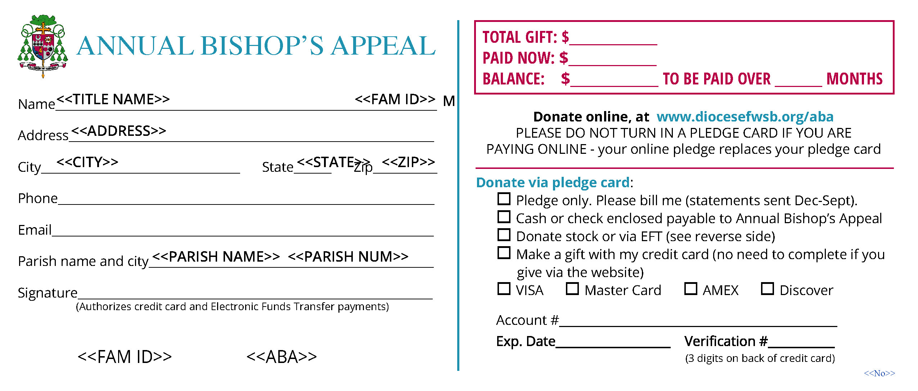

Reverse side of pledge card

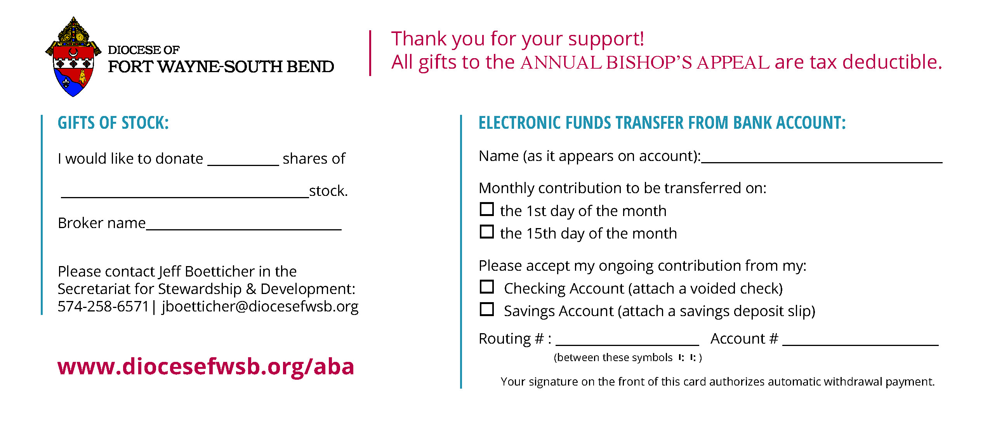

Auditing Procedures- Receiving Pledges

If parishioners are completing blank pledge cards in church, the information they write on the cards should be transferred to an excel spreadsheet, which will be provided for each parish. Enter the donation amounts for each donor on your excel spreadsheet, and fill out a Transmittal Report, then email to the Business Office. If you are not using the excel spreadsheet, you need to rewrite the pledges on each donor’s preprinted pledge card (if you use preprinted pledge cards, you should have already ordered them with your ABA supplies), which are then sent to the Diocesan Business Office to be scanned. If you are using the excel spreadsheet and have entered the donation amounts, you will not need to send the preprinted pledge card, because it does not need to be scanned.
Please note, credit card and EFT pledges cannot be submitted on an excel spreadsheet -these pledge cards will need to be sent to the Business Office for processing (via Fedex, see instructions below). For credit cards and EFT, you must rewrite the donor’s information on a preprinted pledge card (so it has their Family ID number), and send that to the Business Office with a Transmittal Form. When submitting credit card donations, please separate into two batches: Credit Card, Pledged & Paid in full, and Credit Card, Balance Due. Please fill out a Transmittal form for each batch.

Please encourage your parishioners to go to our website, diocesefwsb.org/aba to enter their credit/debit card donations, as this is a more secure method for them, and also saves processing time for parish and diocesan staff.

If you do not have a pre-printed pledge card for a family, fill out pledge on a blank card, and include the Family ID number (can be found in ParishSoft). Please do not use another family’s pre-printed pledge card and write in a new family, because the pre-printed cards have a family ID at the bottom of the card specific to the family printed on the card. It is important to have the correct family’s pledge with the family ID as the cards are scanned and imported into our pledge records.

- The parish must already have donor families set up in the Parishsoft census program.

- If the family is not entered when the diocese receives the pledge cards, the diocese will enter the family as a Registered, Contributor Only so that the parish receives credit for the pledge.

- After the pledge has been entered the parish can keep this family record or remove them.

You may now enter gifts for both Major/Advance donors and General donors on your excel spreadsheet. These include “Pledge Only”, “Gift with Pledge”, and “Paid in Full” using a check for payment. Again, EFT and Credit Card gifts cannot be submitted on an excel spreadsheet.

Bank Deposits

1. Run a calculator tape on checks/monies received.
2. Run another tape on "Paid Now" Section of the pledge cards.
3. The two tapes must be in agreement before you send the monies to the bank for deposit.
4. When you record the deposit in the parish books, the entry should be:

Debit Cash Account #110.110 $_________
Credit Annual Bishop’s Appeal Transfer, Account #220.110 $____________

Sending Cards to the Diocesan Business Office

Please keep credit card and electronic transfer pledges with payments separate from regular pledges with payments by check. A separate transmittal form should be completed for credit cards and electronic transfers. Please make sure that all donor information and pledge amounts are legible.

When sending cards to the Diocesan Business Office, please do the following:

1. For the larger parishes (if you have more than approximately 150 cards for the week), please make several batches, each one not more than 1½" high, and each with its own parish check. A sufficient number of “first class postage paid envelopes” will be provided to each parish for mailing to the Diocesan Business Office.

2. Run a calculator tape on the Total Gift section of the cards.

3. Run another calculator tape on the Paid Now section of the cards.

4. Send the cards, the balanced calculator tapes, the transmittal form, and a check for the amount paid--made payable to the Annual Bishop's Appeal. Please do not send cards for “zero” pledges or calculate “zero” pledges in your totals.

Please issue a separate Transmittal Form and Check for each stack of cards.

5. When you record the check to the diocese in the parish books, the entry should be:

Debit Annual Bishop’s Appeal Transfer Account
#220.110 $ ________
Credit Cash Account #110.110 $ ________

6. Most parishes, depending on size, should send in their pledge cards weekly during October and November. All cards are due in the diocesan Business Office by November 20th. Please do not hold pledge cards. It is important to submit all cards by November 20th, since Bishop Rhoades will be sending a thank you postcard to all contributing families in mid December. Also, your donors may not receive proper tax credit for the year they donated if you do not get their pledges sent in by the end of November.

Use of Credit Card

The donor may go to our website and make their donation. If they prefer to write their credit card donation on a blank pledge card, they should write in the type of credit card, account number, expiration date and the three digit code on the pledge card. The parish then needs to rewrite the donor’s information on a preprinted pledge card (so it has their Family ID number) and send that to the Business Office with a Transmittal Form. Please make sure pledge cards are legible, and have the correct Family ID so we are able to process them. When submitting credit card donations, please separate into two batches: Credit Card, Pledged & Paid in full, and Credit Card, Balance Due. Please fill out a Transmittal form for each batch.

No bill will be sent to donors using credit cards or electronic transfer unless the credit card has expired or there are not enough funds in the account.

Sending Credit Card and EFT pledges & payments to the Business Office via Fedex

Credit card and EFT payments and pledges sent from parishes to the Diocese must be sent via secured carrier. Therefore, we are sending you an initial supply of FedEx envelopes for this purpose. When you run low, please call Liz Jones in the Stewardship & Development Office, at 260-888-1224 to have your supply replenished. To fill out the FedEx label:
- Section 1- enter date
- Section 2- skip
- Section 3- Enter Deb Gase for “name”, Diocese of Fort Wayne-South Bend, 915 S. Clinton St., Fort Wayne, IN 46802-2601.
- Section 4- Check “FedEx Express Saver”
- Section 5- Check “Fedex Envelope”
- Section 6- Check “No” where it asks whether the package contains dangerous goods
- Section 7- Check “Recipient”

Keep the top copy of the airbill for your records, then insert the airbill in the plastic pouch on the back of the FedEx envelope. Call 1-800-463-3339 to schedule pickup, or drop the envelope in a FedEx drop off site. If you have any questions, please call the Diocesan Business Office at 260-399-1421.

Electronic Transfer

What is electronic contribution?

Electronic contribution is an automatic transfer from your checking or savings account, which allows you to make contributions to the Annual Bishop’s Appeal without writing checks. An alternative is going online, to diocesefwsb.org/aba and donating with your debit card.

How do I sign up for electronic contribution?

Complete and sign the authorization form on your pledge card and return it to the parish office with a voided check or savings deposit slip.

How is my electronic contribution automatically deducted from my account?

Once you authorize the transfer, your specified contribution is electronically transferred directly from your checking or savings account to your parish Annual Bishop’s Appeal account- donor’s signature on the of the front of the pledge card authorizes payment.

When will my contribution be deducted from my account?

Your contribution will be deducted from your account on the 1st or the 15th of the month (whichever you specify). You can set up payment for up to 12 months.

What if I change bank accounts?

If you change bank accounts, you can simply call the Diocesan Business Office (260) 422-4611, extension 3340, and give them the new information, or you can mail the new account information to the Diocesan Business Office, P.O. Box 390, Fort Wayne, Indiana 46801.

How much does electronic contribution cost?

It costs you nothing and saves you time.

What if I try electronic contribution and do not like it?

You can cancel your authorization for electronic contribution any time by notifying us in writing or email: jboetticher@diocesefwsb.org.

Stock Donations

Stock donations to the Diocese of Fort Wayne-South Bend for the Annual Bishop’s Appeal continue to increase annually. We want to accommodate our donors in the most effective way possible; however, we also want to realize the greatest net proceeds to the beneficiary location. To help accomplish this, we are offering a program through Northern Trust. Their fee is a flat $30 for 1-700 shares and a flat five cents per share for trades over 701 shares. The net proceeds will be greater in most transactions with these terms.

Account information for Northern Trust is as follows.

Northern Trust Securities, Inc. (NTSI)
Account Name Diocese of Fort Wayne-South Bend, Inc.
Account # NT2-085324
DTC# 0226

Please have your broker inform the diocesan business office of:

- Name of donor
- Name of stock
- Number of shares
- Date of stock transfer
- Purpose of the gift
Your broker can inform by letter:
Jeff Boetticher,1328 W. Dragoon Trail, Mishawaka, IN 46544
Or e-mail to jboetticher@diocesefwsb.org
Phone # 574-258-6571

Payments

Monthly payments on pledges to the Annual Bishop’s Appeal should be made directly to the diocese, not to the parish. All checks should be made out to the Annual Bishop’s Appeal. Billing for pledges is for 10 months, December to September, and monthly statements/ reminders will be sent out by the Business Office.

Payments received in the Offertory

While donors should send all payments directly to the diocese, sometimes they drop them in the collection basket. When that happens, just write a note saying "Pledge Payment" and paper clip it to the check; please do not staple. Then, mail both to the Diocesan Business Office.

Please do not send a duplicate pledge card with a payment that is made on a previous pledge.

Please do not staple anything to the pledge card. The pledge card is the “main source document” and must be kept free from holes or scratches so it can be read properly on an automated machine.

Please send your donations to the Business Office in a timely manner, so your donors receive tax benefits in the current tax year. For example, a donor gives a check to the parish November 15th, but the check is not sent to the Business Office until January 2nd. The donor may not get the tax credit in the year they intended.

Transmittal Report

Please use the Transmittal Report form when reporting (see below for example, and go to https://diocesefwsb.org/aba-toolkit/ to print this form).

Mail or deliver this form and your parish check in a prepaid envelope to:

Data Processing, Diocesan Business Office
Diocese of Fort Wayne- South Bend
P.O. Box 390, Fort Wayne, IN 46801

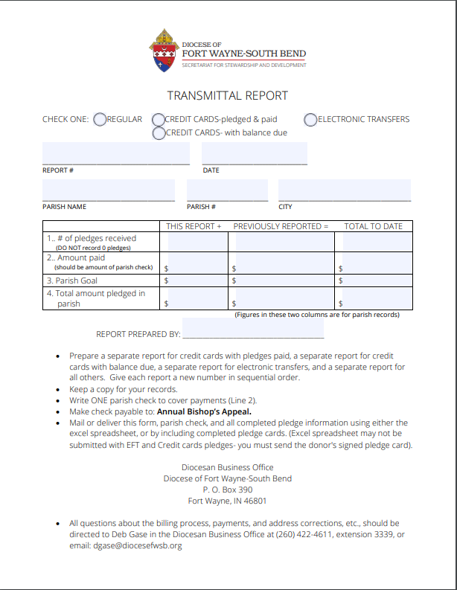

Frequently Asked Questions

What is the Annual Bishop’s Appeal?

The Annual Bishop’s Appeal is an annual fund drive conducted by each parish within the Diocese of Fort Wayne-South Bend to raise the funds needed to provide our diocesan ministries and services.

How does the Annual Bishop’s Appeal benefit my parish and me?

You, and thousands of others from the Diocese of Fort Wayne-South Bend, are served through the diocesan ministries and services. These services include:

Clergy

Our diocese has 18 men studying for the priesthood. Strong human intellectual, spiritual, and pastoral formation for a future priest is of great importance. We also have 19 men studying in the permanent diaconate program. Your generosity supports:
- Seminarian formation
- Diaconal formation
- Continuing formation for priests and deacons
- Support for retired priests

Catholic Education & Faith Formation
Catechetical and spiritual formation, for all ages, strengthens our Catholic faith and nurtures our life in Christ. The Bishop’s Appeal supports the teachings of
the faith in many ways:
- Tuition grants for needy Catholic high school students
- Catholic Schools Office-admin support for our 43 Catholic schools
- RCIA ministry support
- Foundations of Faith–training program for catechists
- Continuing education for Catholic school teachers

Communications & Ministries
The Bishop’s Appeal supports ministries and services, bearing witness to Christ in the following areas:
- Hispanic Ministry
- Youth Ministry- faith formation at our 4 diocesan high schools
- Today’s Catholic–diocesan newspaper
- Marriage and Family Ministry

Charity & Pastoral Ministries
As disciples of Christ, we are called to have a special love and concern for the poor. Many charities receive funds from the Bishop’s Appeal, providing services to those in need:
- Food, clothing and medical care for the poor
- Serving the homeless
- Crisis pregnancy and adoption services
- Refugee resettlement and placement services
- Persons with disabilities services
- Victim assistance
- Jail ministry

Donors to the Annual Bishop’s Appeal are helping not only people in our parish, but also 80 other parishes throughout the diocese.

Why emphasize pledges?

The Annual Bishop’s Appeal emphasizes pledging for ten months, billed by the diocesan business office (or 12-month payments with credit card or electronic transfers). Pledges allow individuals and families the opportunity to consider larger commitments than they could usually consider when making a one-time gift. Experience in past campaigns shows that donors who pledged were able to consider gifts four to five times larger than those who made one-time gifts.

How much should I pledge?

That is entirely up to you. You know your financial situation. The diocese recommends people consider a gift of one percent of their income to the Annual Bishop’s Appeal. Examine your heart and give a prayerful response. When you are at peace about your gift and no longer find yourself making excuses about your gift…when you know in your heart that you have been honest with God…then you have given a gift in gratitude for God’s blessings upon you.

If I do not give, will it affect our parish?

Yes, our parishioners are asked to help us reach our parish goal for the Annual Bishop’s Appeal each year. If our goal is not met, our parish must make up the difference using funds from our regular weekend offertory collection. The good news, however, is that any money collected in excess of our assessment is returned to the parish

What if I am afraid to make a pledge?

A pledge to the Annual Bishop’s Appeal is not legally binding. It is simply a statement of the donor’s intention to provide support for our diocesan ministries. If your situation changes, we will certainly understand. Just call the parish office to let us know. Be not afraid.

What about the people who only give a little (or no gift) to the Appeal?
Every parishioner is encouraged to participate in the Annual Bishop’s Appeal, no matter the amount contributed. It is important for us to remember that our gift to the Annual Bishop’s Appeal is not about what others give. It is one of the ways of giving thanks to God for the blessings God has given to each of us and to contribute to the building of His kingdom. It is best if we do not base our gift to the Annual Bishop’s Appeal on what others give but instead view our giving as a personal faith decision based on our income and our ability to give.

What happens when I make a pledge to the Annual Bishop’s Appeal?

Most people prefer to make an initial gift at the time they make their pledge followed by a number of installment payments. You may visit our website, www.diocesefwsb/org/aba to set up your pledge with a credit or debit card, and payments will be billed automatically- this is the safest and most efficient way to process your gift.
If you prefer to be billed and write a check, simply indicate this option on the pledge envelope. The Diocesan Business Office will send you payment reminders December through September. (The Diocesan Business Office can send only ten statements. However, 12-month payments may be made if paying with a credit card or electronic transfer from checking or savings account.)

